Creating VM in GCP
- First go for compute engine and then select create instance and then click on new instance
- 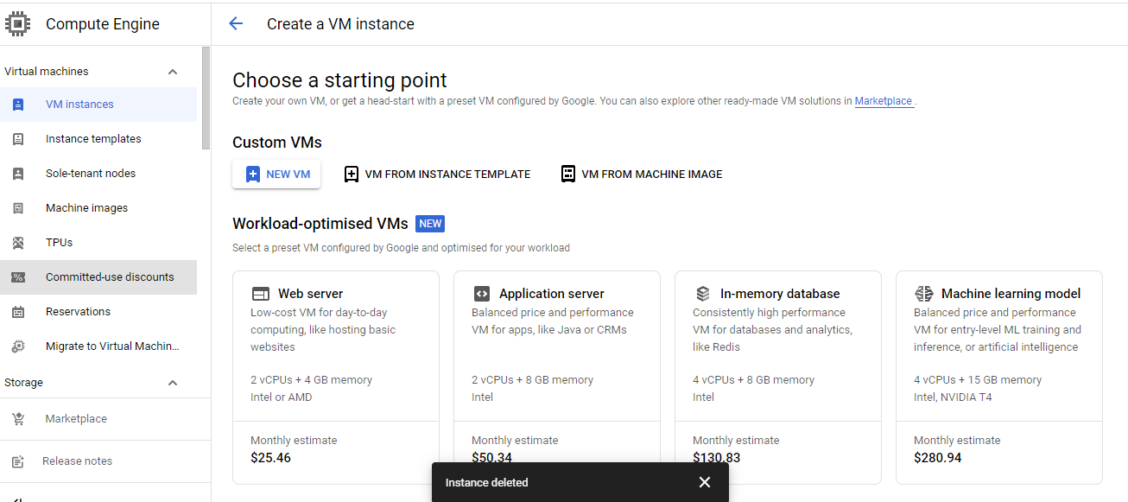
- Create new VMs
- Then give one name and leave the things as it is
- 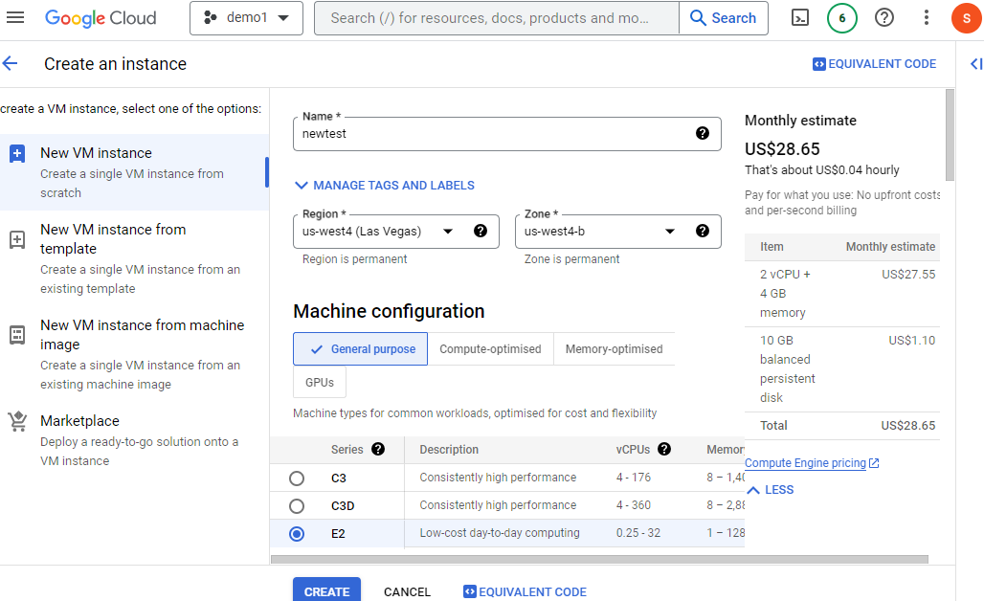
- First you need to change the os to red hat or linux
- This is available in boot change option, here you can change the os to redhat and also click on pay as you go .then you can do the below options.
- 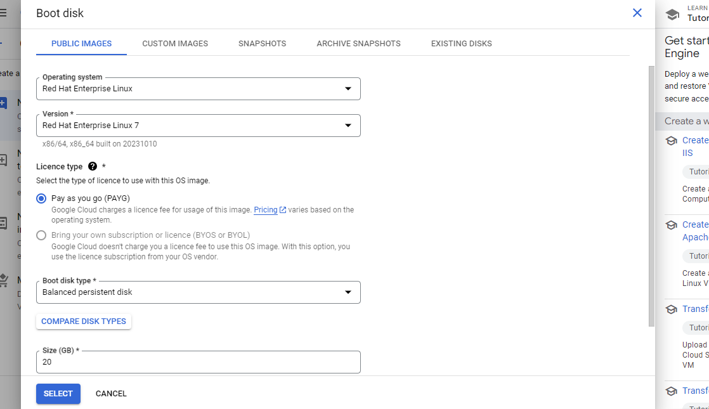
- After that come down and tick for allow https,http and one more option.
- 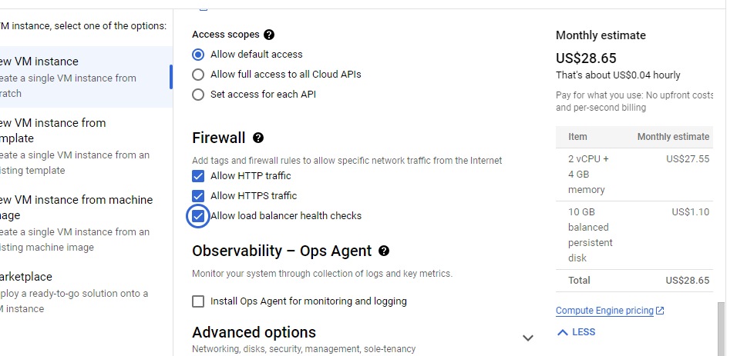

- Then click on create.
- 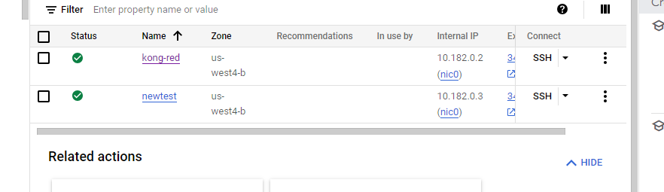
- After this step you need to create a pem file using puttygen
- 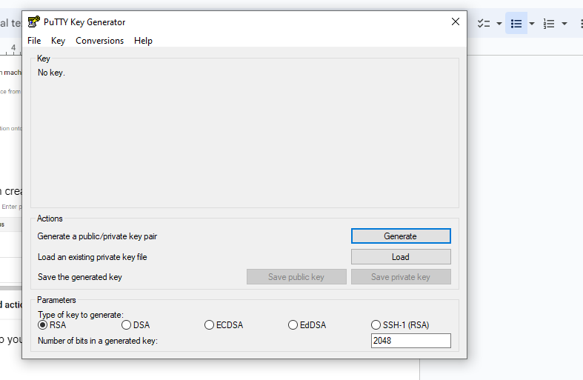
- Click on generate
- After clicking on generate hover your mouse continuously on the green line, until it becomes full you need to keep on hovering on it.
- 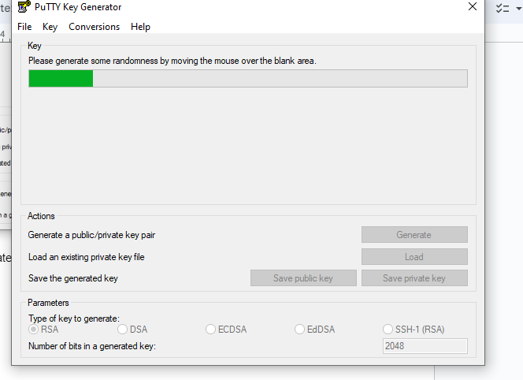
- Once it becomes full remove the default key comment, add the new key comment and then key comment you can give ur name and then in keyphrase give the password and then add confirm password also but important you need to copy the public key for pasting into open ssh authorized key file this you need to copy the entire code and then paste it new notepad
- 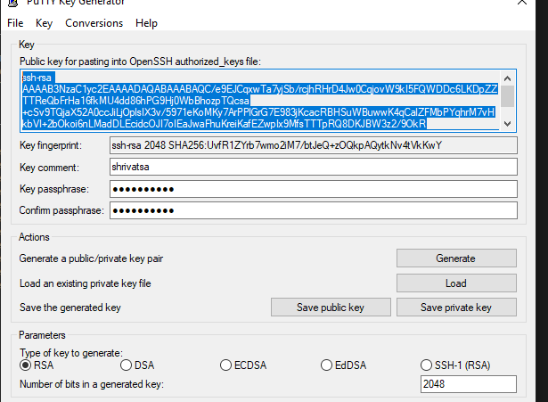
- Here below I have copied the public key in notepad.
- 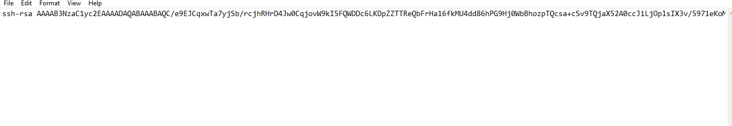
- Then save the public file and private file in downloads.
- Then copied public key must be added into the gcp as a key as shown below
- Click on the edit and then add the copied key
- 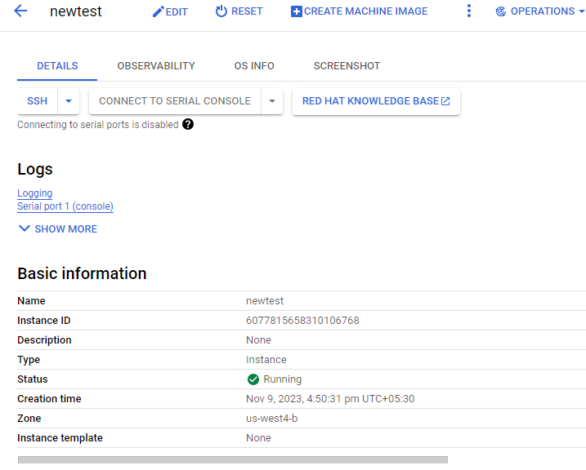
- Then come down and add the key below, there is a place called as ssh key add item there you need to paste the key
- 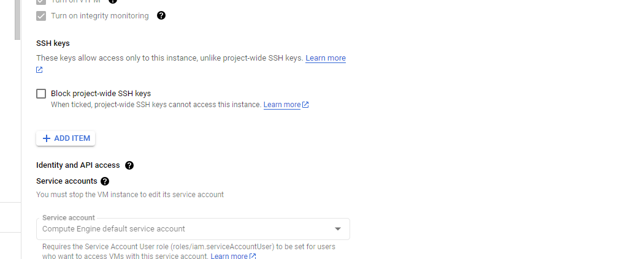
- Here paste the key and then save it
- 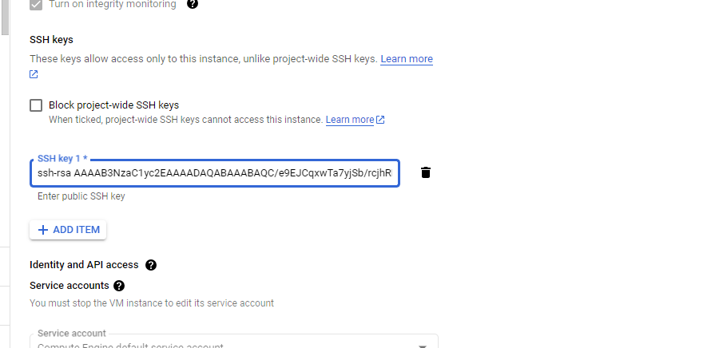
- Then you need to save it and this is the place where you need to add ssh key
- Then after saving come to mobxterm then you need to give ur public ip and username u need to give as the key comment name which is shrivatsa then some times when you login it will ask for password then you need to give keyphrase as password also you need to provide pem file.
- 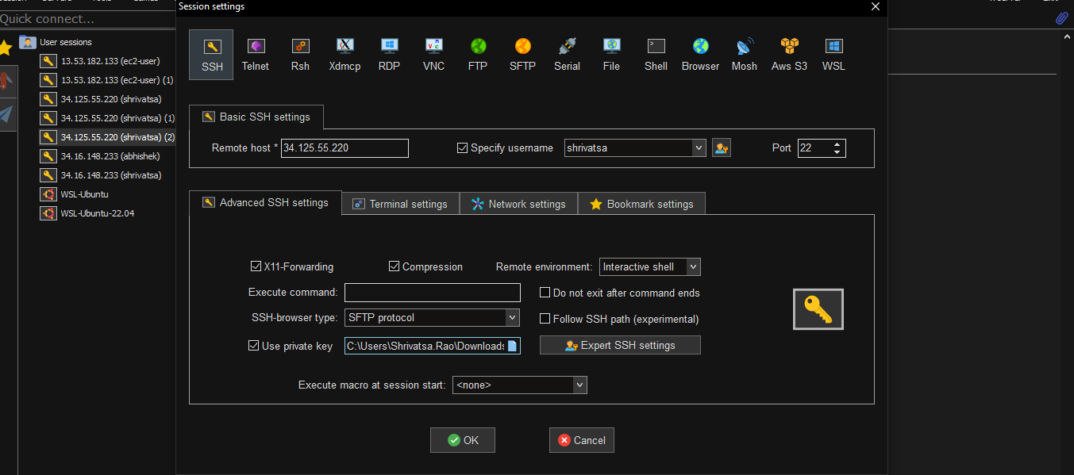
- Then you can easily connect.

